15BCE0517

M.S.SANJAY

L3+L4

DATA MINING LAB

EXPERIMENT 8

**SIMULATION OF PAGERANK ALGORITHM**

>library(igraph)

> g <- graph(c(

+ 1, 2, 1, 3, 1, 4,

+ 2, 3, 2, 6, 3, 1,

+ 3, 5, 4, 2, 4, 1,

+ 4, 5, 5, 2, 5, 6,

+ 6, 3, 6, 4),

+ directed=TRUE)

> M = get.adjacency(g, sparse = FALSE)

> M = t(M / rowSums(M))

> n = nrow(M)

> U = matrix(data=rep(1/n, n^2), nrow=n, ncol=n)

> beta=0.85

> A = beta*M+(1-beta)*U

> e = eigen(A)

> v <- e$vec[,1]

> v <- as.numeric(v) / sum(as.numeric(v))

> v

[1] 0.1547936 0.1739920 0.2128167 0.1388701 0.1547936 0.1647339

> page.rank(g)$vector

[1] 0.1547936 0.1739920 0.2128167 0.1388701 0.1547936 0.1647339

> page.rank(g)$value

[1] 1

> plot(g)

>

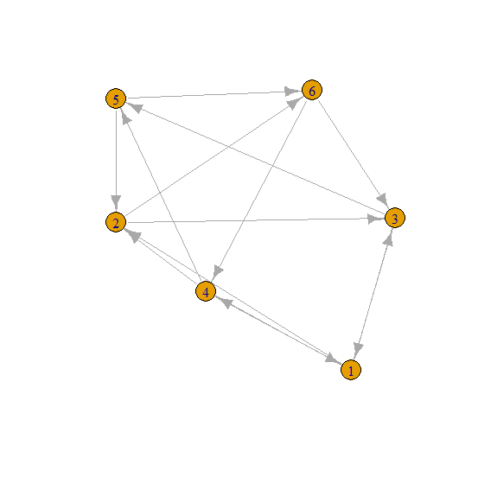

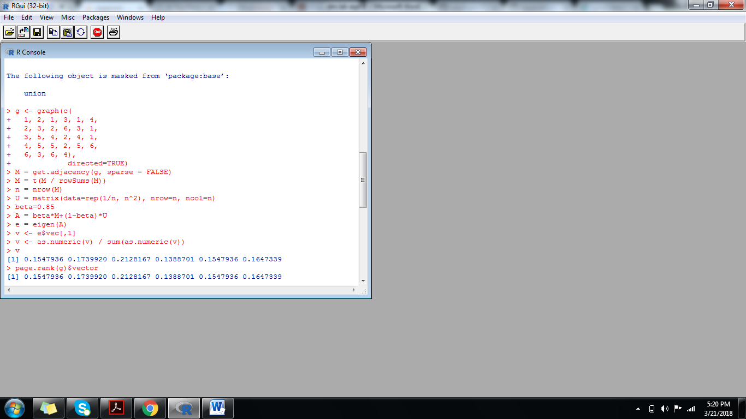

**DEMONSTRATION OF HUBS AND AUTHORITIES:**

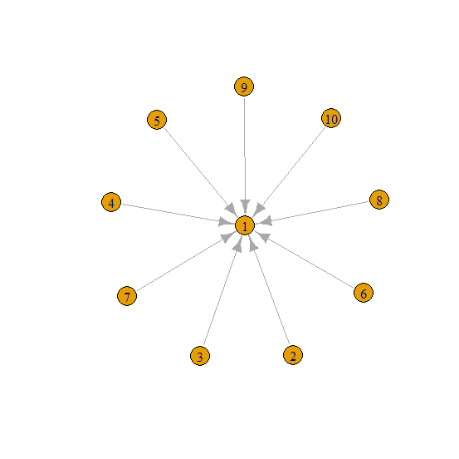

> g <- make_star(10)

> hub_score(g)$vector

[1] 3.3697e-16 1.0000e+00 1.0000e+00 1.0000e+00 1.0000e+00 1.0000e+00

[7] 1.0000e+00 1.0000e+00 1.0000e+00 1.0000e+00

> authority_score(g)$vector

[1] 1.000000e+00 2.493665e-18 2.493665e-18 2.493665e-18 2.493665e-18

[6] 2.493665e-18 2.493665e-18 2.493665e-18 2.493665e-18 2.493665e-18

> plot(g)

> authority_score(g)$value

[1] 9

> hub_score(g)$value

[1] 9

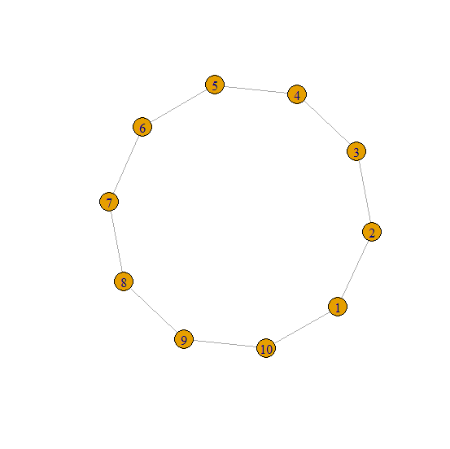

> g2 <- make_ring(10)

> hub_score(g2)$vector

[1] 1 1 1 1 1 1 1 1 1 1

> authority_score(g2)$vector

[1] 1 1 1 1 1 1 1 1 1 1

> plot(g2)

> authority_score(g2)$value

[1] 4

> hub_score(g2)$value

[1] 4

